Table of contents

# Introduction

The need for a news verification system came with advancement in the technology field. False rumors are spread daily. This project will focus on verifying news articles, through the use of Blockchain technology. Once an article is verified, it will be added to the chain and displayed under verified articles. Each user builds credibility through each article the user verifies.

# Implementation

## Implementation with Web Technology

## 2.2 Implementation with App Technology

## 2.3 Implementation with Cloud Technology

## 2.4 Implementation of Blockchain Technology

The project will make use of the multichain technology to create the chain.

# Prototype of Website

A first time visitor to our website will be navigated to the following home screen:

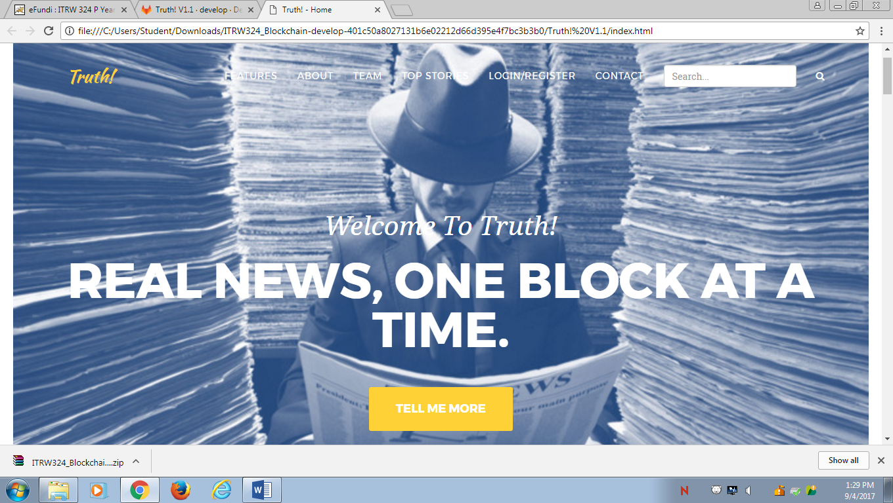

From this home screen the user will be able to navigate throughout the site. The features, about and team information as well as the contact functionality can be navigated to by clicking the tabs in the navigation bar at the top of the site or by simply scrolling down in the home page. What the user will then see is as follows:

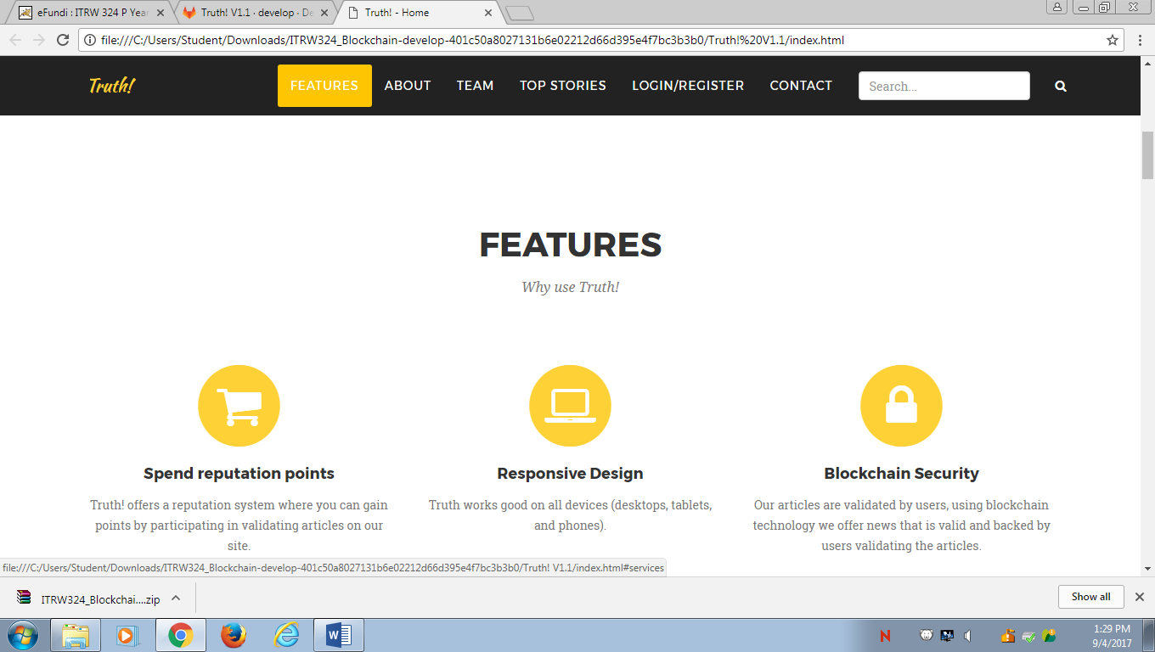

‘Features’ gives information about what makes this site unique and why a user would want to use our site instead of conventional existing sites.

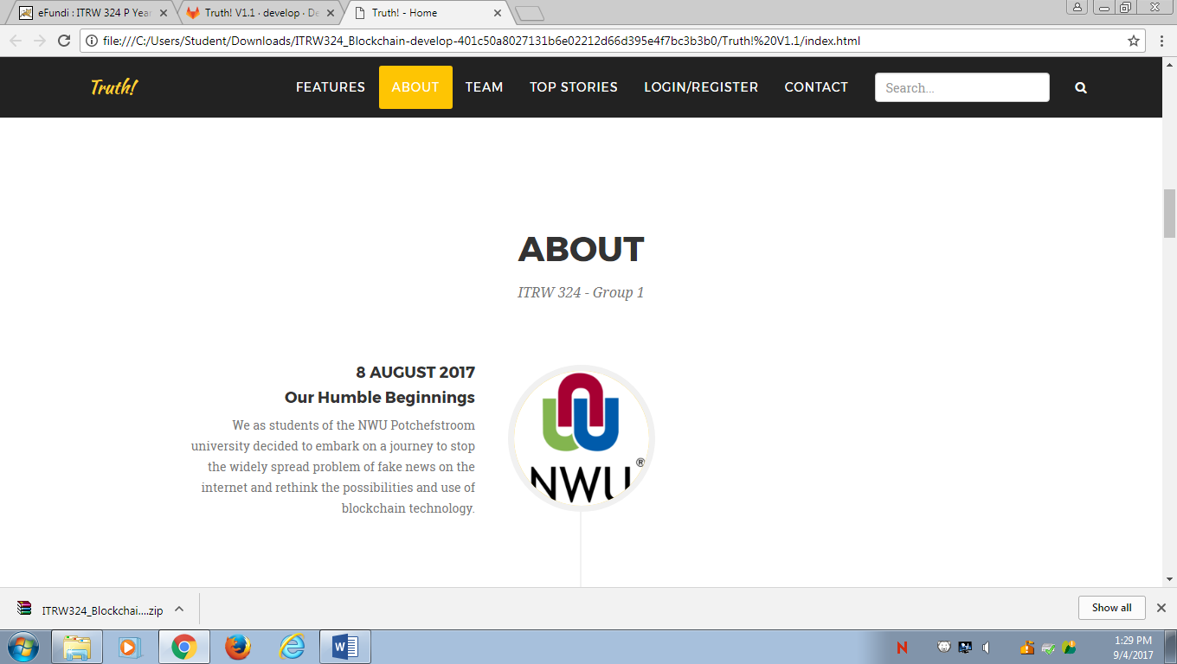

‘About’ will lay out a timeline spanning from the first prototype of our sites, through all the phases ending up at the finished product that will be released and beyond.

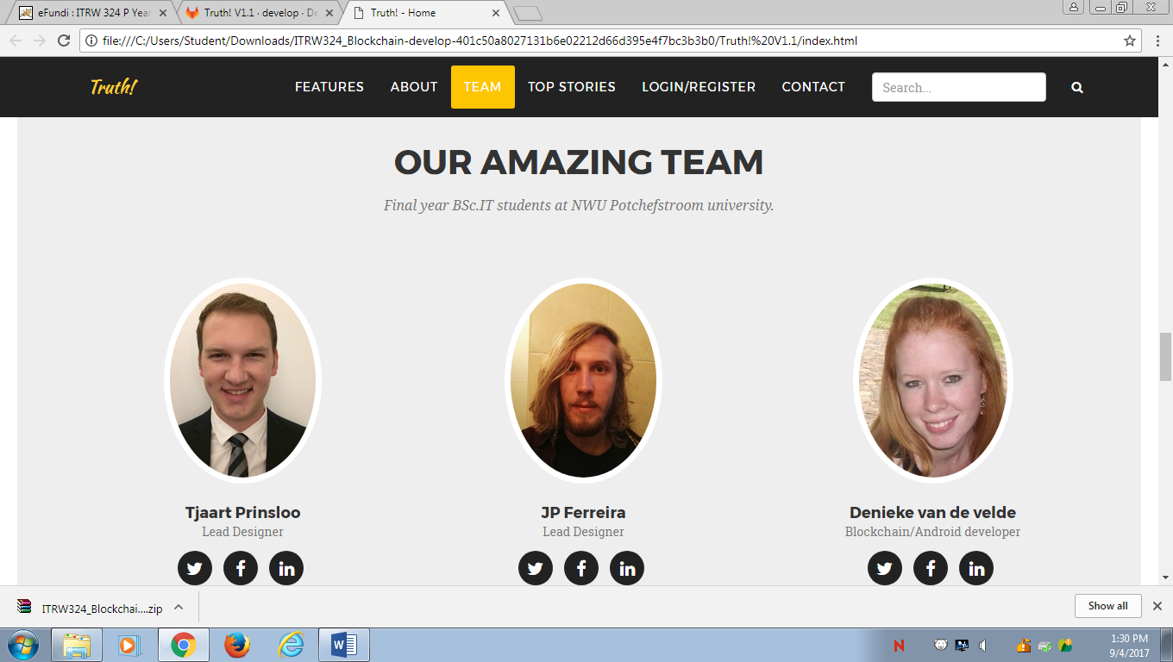

‘Team’ will provide photos, roles and contact information about all members involved in the creation of this system.

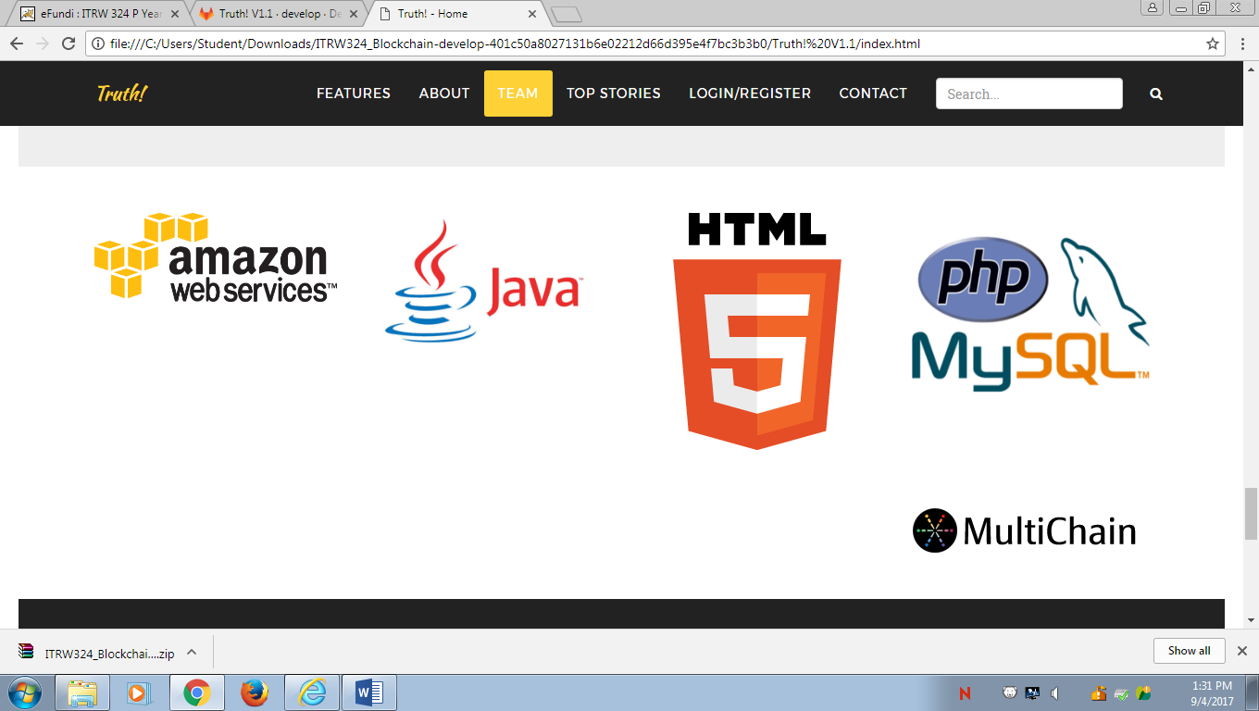

We also provide information about the programming languages and tools used in the development process of the entire system.

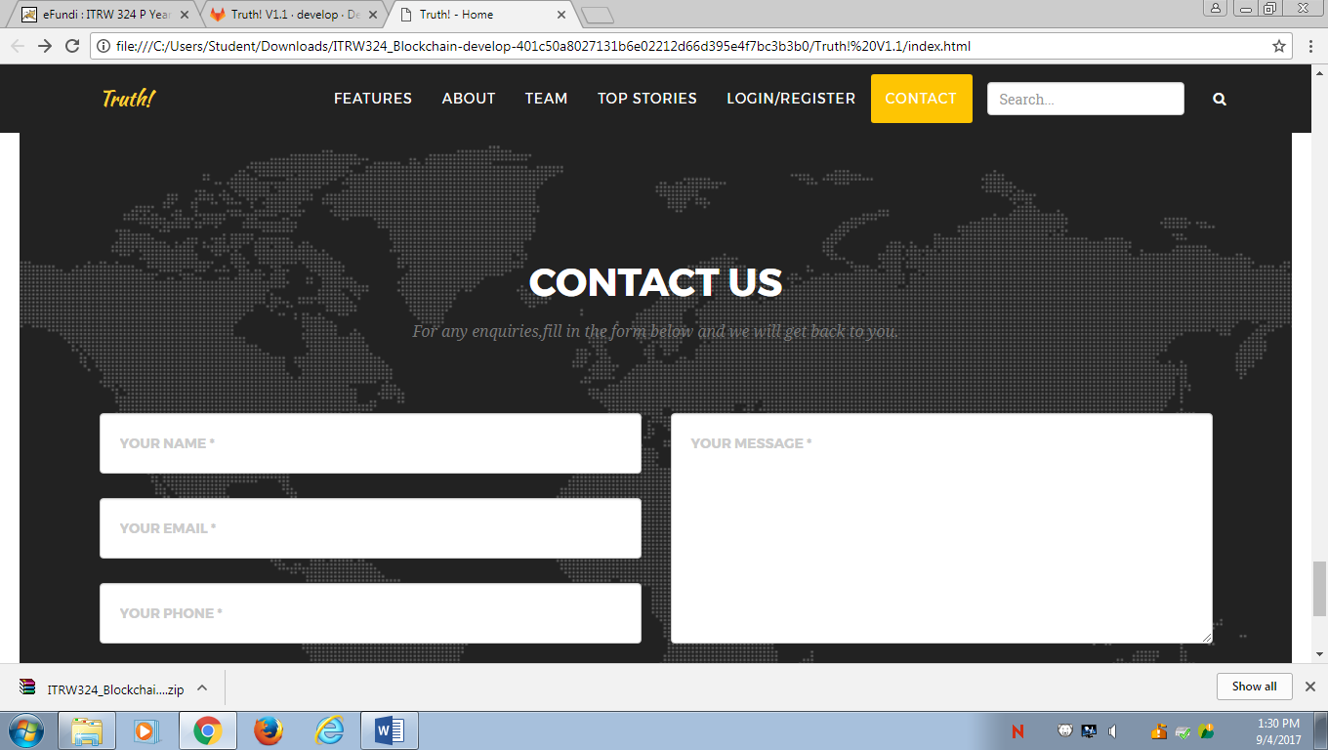

At ‘contact’ we will provide an easy way for users to send us any thoughts, enquiries or complaints via email to a central account that we can monitor and respond to.

Clicking on the ‘Top stories’ button in the navigation bar on the home screen will redirect a user to the following page:

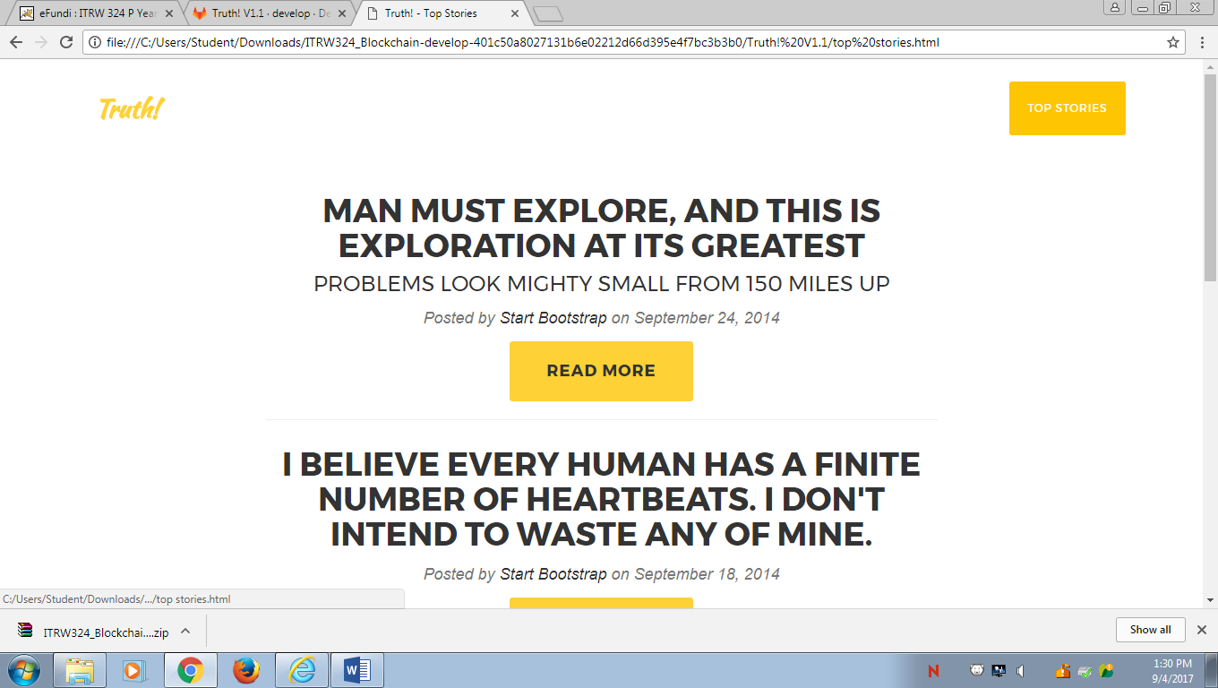

Here the user will find a collection of recent story titles and bits of relevant information uploaded by our admins, along with the relevant information about the trustworthiness ratings the article has received and a ‘read more’ button that will redirect the user to the full article as follows:



Here the entire article can be read as with any news site within our site. The user is not redirected to external news sites to read articles.

At the end of an article, there will be the option to rate and article on a scale from one to four stars. One star indicating a fake article and four stars indicating a trustworthy article. A rating breakdown is also available, showing how other users have voted so far.

Your rating will then contribute to the overall trustworthiness score of the article according to the weight of your reputation. This trustworthiness score will be available next to the titles of all articles and will determine if the majority of users see the content as fake news or trustworthy, to help readers decide if they want to navigate to and read the article in the first place.

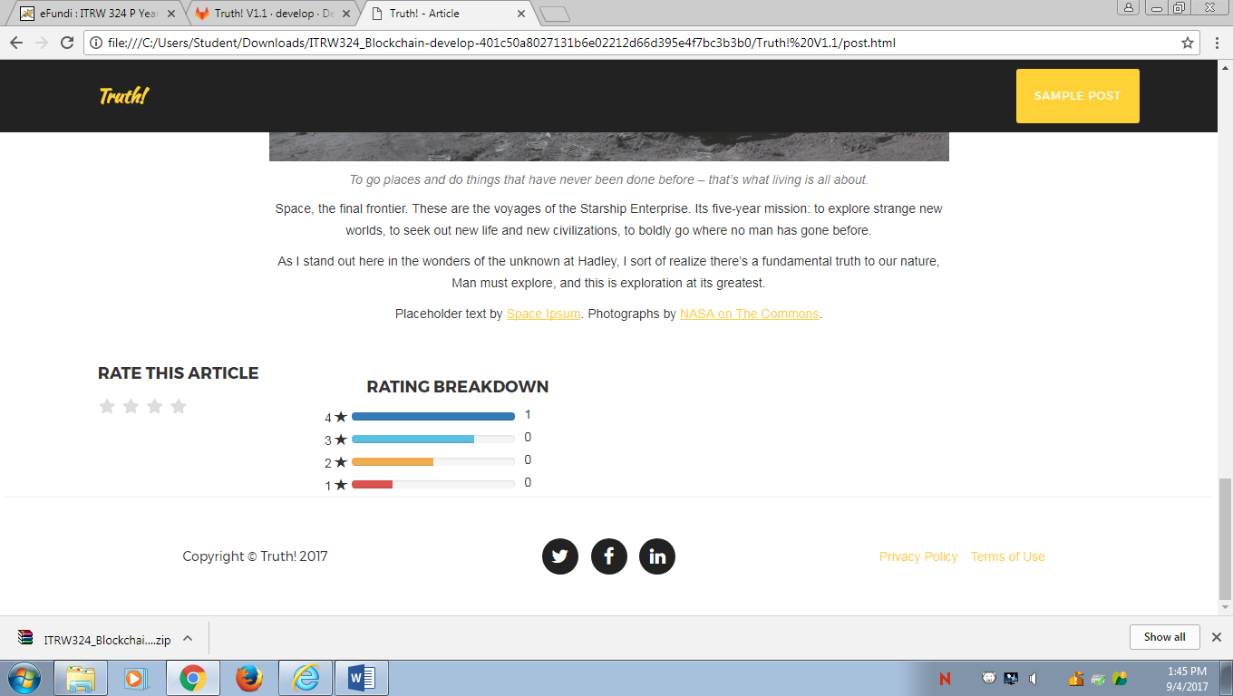

The ‘login/register’ tab on the home page navigates the user to a joint page where both functions can be selected according to the user’s needs. This is quite standard, where a user can either create an account by giving a username, password and email, or the user can login to an existing account, which will enable them to contribute to article ratings and build their reputation.

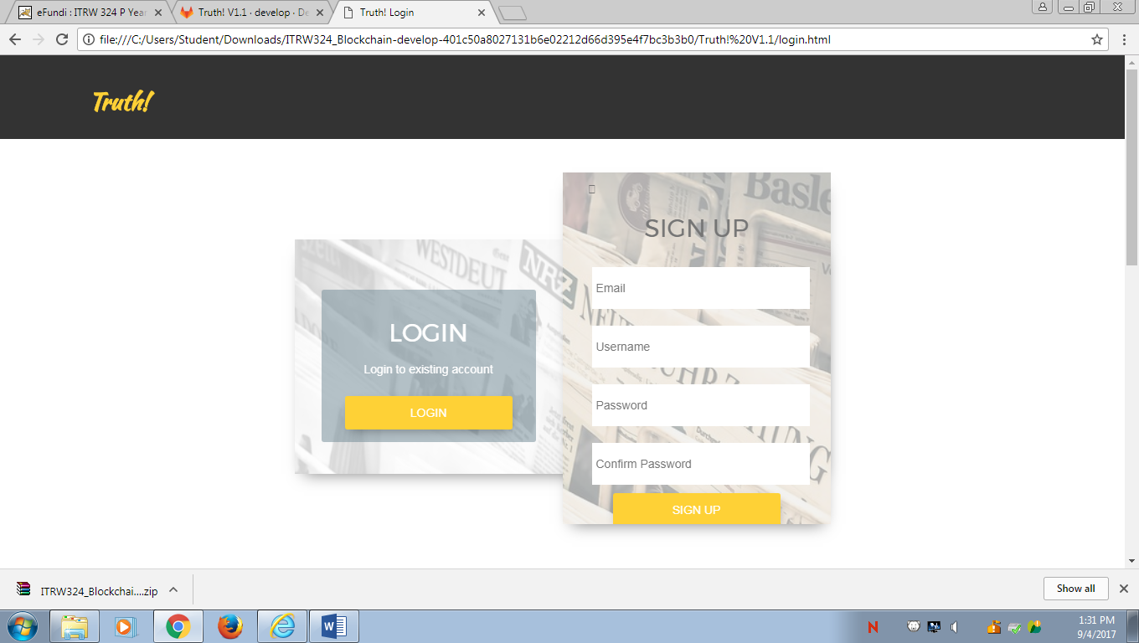

# Work Breakdown Structure

# Task-Prioritization Matrix

# Overall Progress

The web-service took longer than expected, which delayed the project. The team members is still working on the Blockchain.